Guidelines for ClusterXchange virtual exchanges

Introduction
ClusterXchange (CXC) is a pilot scheme for short-term exchanges between actors of different industrial clusters. The CXC is funded by the European Union (EU) and is implemented by the European Strategic Cluster Partnerships for Excellence (Partnerships).

An exchange in the CXC constitutes a stay abroad by a visiting organisation (visitor or VO) at a host organisation (host or HO) to explore collaboration and growth opportunities. Virtual exchanges have been temporarily allowed (under certain conditions) in the CXC due to the COVID-19 pandemic that is heavily impacting the possibility for physical exchanges to take place across Europe.

This document provides guidelines to the Partnerships on facilitating the administration of virtual exchanges under the CXC. The document is structured as follows:

- ClusterXchange virtual exchange rules;
- Overview of the virtual exchange administration process;
- Profile creation (registration);
- Matching;
- Exchange building;
- Exchange execution;
- Annex 1. Commitment to Quality for virtual exchanges
- Annex 2. Final activity report for virtual exchanges – Host Organisation
- Annex 3. Final activity report for virtual exchanges – Visiting Organisation

ClusterXchange virtual exchange rules

- Participants of a virtual exchange are not eligible to receive the financial assistance;
- If a participant takes part in a virtual exchange, he/she can still take part later in a physical exchange and receive financial assistance for this physical exchange (provided the minimum duration/requirements are met as set in the Quality Manual) as set out in the call and respective grant agreements;
- Virtual exchanges can be counted towards the Key Performance Indicators (KPIs) related to the number of exchanges to be performed, however, the rules as regards the minimum duration (three working days) and maximum duration (one month) of an exchange must be respected. Virtual exchanges shorter than 3 working days can take place as preparatory exchanges for a physical exchange but cannot be counted towards the KPIs.
- A virtual exchange does not have to take place in consecutive days but it must be performed within a certain period of time, depending on the length of the exchange. Formula to calculate this period is the following - the exchange must be implemented within 2X weeks equal to the X of planned working days of an exchange. For example, if a 4 working day exchange is planned, it must be implemented within 8 weeks – e.g. 8 half-day sessions within an 8-week period.
- Working days spent in a virtual exchange and a physical exchange cannot be cumulated in order to receive the financial assistance. For example, 1 day of a virtual exchange and 2 days of a physical exchange does not meet the minimum duration of 3 working days set for an eligible exchange and, therefore, a participant would not be entitled to the financial assistance.
- If a virtual exchange takes place (minimum 3 working days and therefore counted towards the KPI), the consortium could propose to EASME to shift the amount in EUR that was earmarked for the financial assistance for the respective exchange from cost category “Costs of financial support to third parties” to other cost categories to implement other cluster capacity building activities. On the other hand, the amount that was earmarked for an exchange could still be used for a physical exchange as initially planned.
- Maximum number of virtual exchanges is limited to 50% of the target. For example, if a Partnership´s target is to have 50 exchanges, the maximum number of virtual exchanges would be 13.
- All other rules remain the same, as stipulated in the Quality Manual.
- This exceptional measure for implementing virtual exchanges will apply until the 31 August 2021. Please note that this end-date is indicative and could be modified by EASME in the next months, depending on how the situation will evolve. The situation will be constantly reassessed.

Overview of the virtual exchange administration process

The CXC IT tool (also referred as IT Tool) aims to facilitate the exchanges from an administrative perspective. In case of virtual exchanges, only a part of the administration processes is managed via the IT Tool. The remaining processes are implemented outside of the IT Tool.

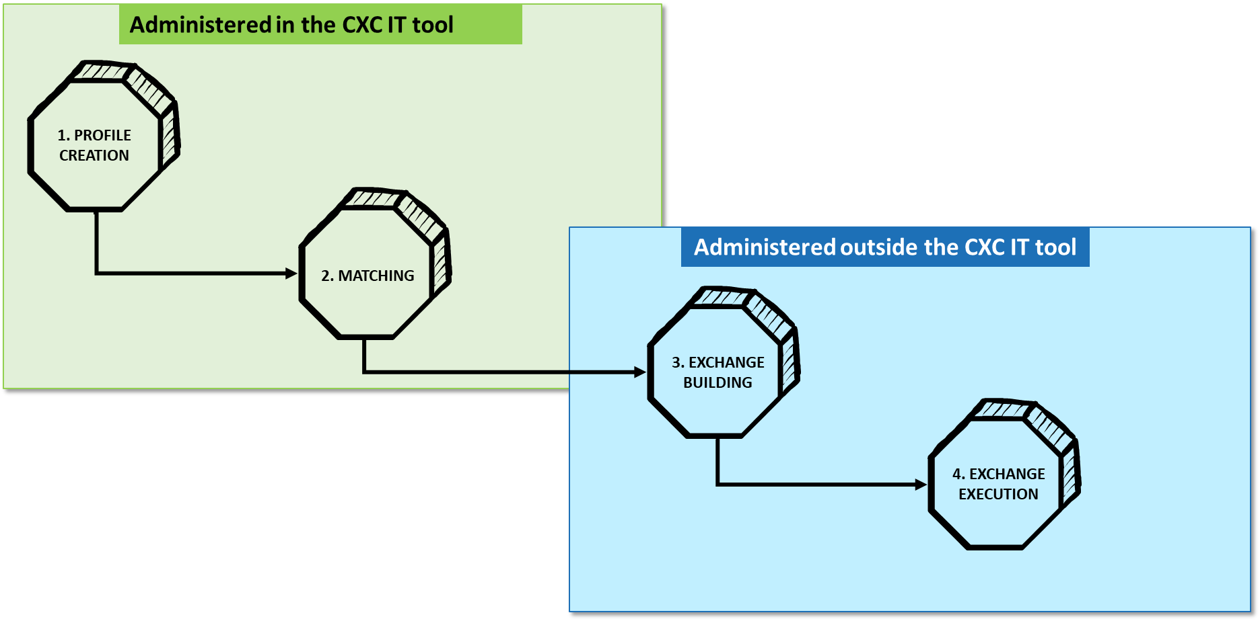

Figure 1: Overview of the administration of the virtual exchanges in regard to the IT Tool

More information is presented in the following chapters.

Profile creation (Registration)

IT Tool Access
To enter the IT Tool, it is necessary to be logged in on the ECCP website (https://www.clustercollaboration.eu/). To log in, click on the 'Login' button and enter, or if you do not have yet an account, click on 'Create a new account' and proceed with the account creation steps. The same login details can then be used to access the IT Tool. To enter the IT Tool, go to the CXC portal located at https://www.clustercollaboration.eu/clusterxchange, click on the “Click here to register” button and insert your ECCP login details. The preview of the login page of the CXC portal is provided in Figure 1.
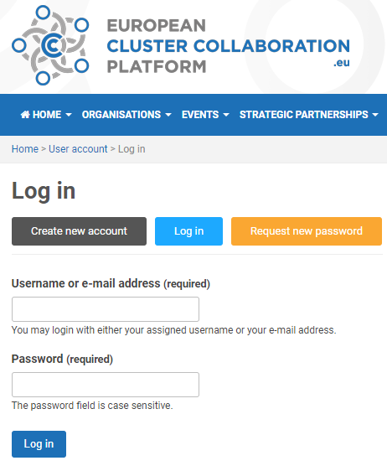
Figure 2: CXC portal login
If you are not logged in the ECCP when entering the IT Tool, you will be redirected to the ECCP login page. After logging in, you will be redirected to the IT Tool.

Partnership Admin access
In order to have access to the part of IT Tool and the permissions reserved for Partnership administrators, the logged in user needs to be associated to the administration team of the ESCP-4x profile of the Partnership in the ECCP website. Users included in the ESCP-4x profile administration team will be able to edit the profile, add news and event articles related to the partnership inside of the ECCP platform, as well as have access to the administration of profiles in the IT Tool.
To add users to the ECCP Partnership´s ESCP-4x profile administration team, an existing profile administrator needs to add the new team member by following the instructions here.

User access
Users that wish to participate in the CXC also need to have an ECCP user account to access the CXC IT Tool as mentioned above.

IT Tool home page
After logging in, the IT Tool administrator is directed to the home page/dashboard for participants of the IT Tool. To access the administrative pages of the IT Tool, click on the “Admin” menu item in the navigation bar:
Figure 3: IT tool admin menu bar

Profile creation and validation
The users will need to register their organisation on the IT Tool as Visiting Organisation (VO) or Host Organisation (HO) or both in order to participate in a virtual exchange. Below is the overview of the profile creation process. This process is the same for virtual and physical exchanges.
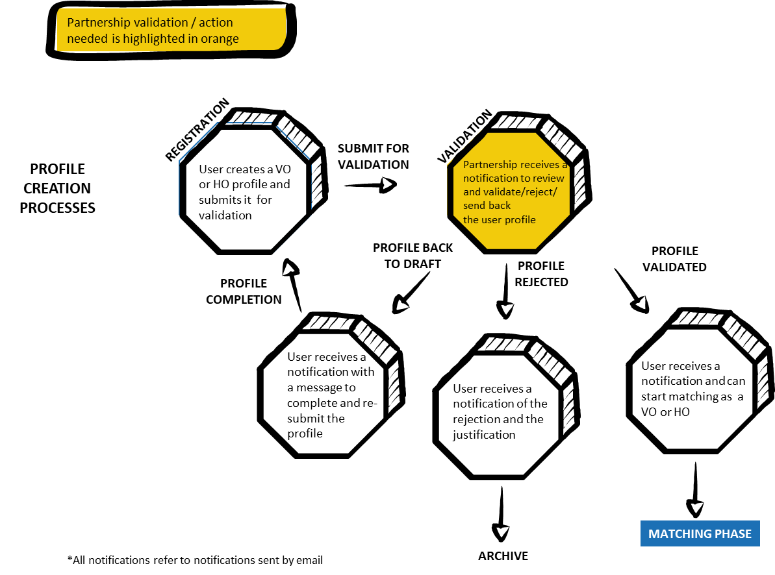
Figure 4: Overview of the profile creation and validation process

In order to start this process, the user needs to click on the “My Profiles” menu item in the main navigation and then click on the “Create new profile” button:
Figure 5: Create new profile button
The user is then presented with the choice to register as VO or HO or both by selecting the two checkboxes, which will create two profiles.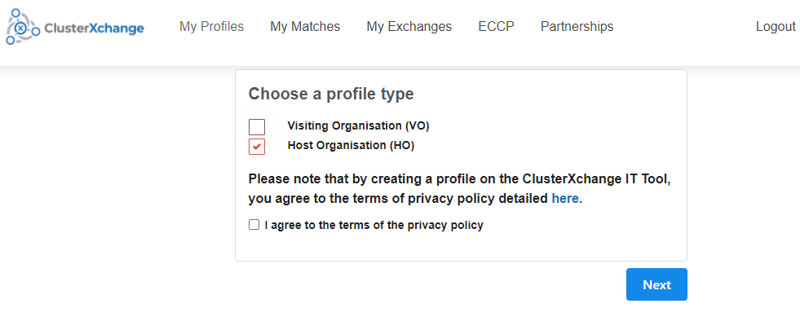
Figure 6: Choose a profile type
The user needs to fill the forms presented to him/her in the profile creation process. The last step of the registration process involves selecting the Partnership that will validate the profile and support the user in the rest of the exchange process.
The selected Partnership will receive a notification when the profile is submitted to validation. To proceed with the validation process, click on the link in the email notification.
- It is possible to send the profile back to draft, meaning that the profile is sent back to the user for completing the information provided.
- It is possible to archive the profile. This will not allow the user to continue the process.
- It is possible to validate the profile, this will make it published and allow its user to continue the exchange process.

Matching
Below is the overview of the matching process for virtual exchanges.

The matching is done on the IT Tool, except the last step related to the validation of the match by the participants. Without a validation, the process will not move to the exchange building phase on the IT Tool. This is important because in this case the same VO profile can be used again for another eventual physical exchange.

In a case where a VO profile enters the exchange building phase on the IT Tool, the same profile cannot be used for another exchange. This is an automatic setting in the IT Tool due to the CXC rules that do not allow the VOs to participate in multiple exchanges in regular situations.

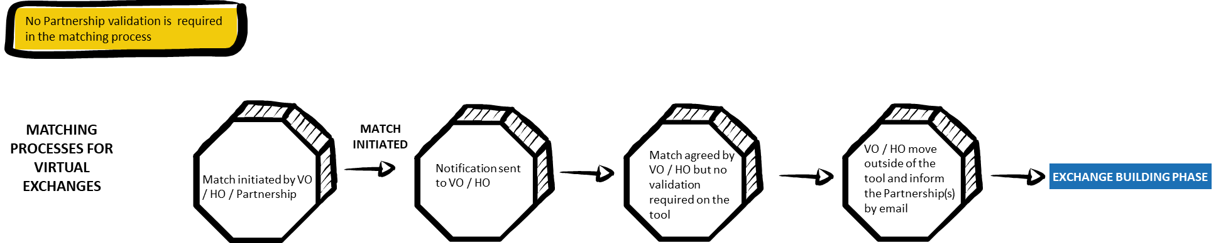

Figure 7: Overview of matching process

When a profile is validated and published in the CXC IT Tool, the system will send a notification email to the user. As the user clicks on the validated profile in the IT Tool (View Button), the IT Tool displays a button with the name 'Find Matches'. The webpage to search matches then appears and allows the user to view a list of organisations registered in the IT tool for the opposite profile with match scores. The match score rating is calculated automatically by the IT Tool.
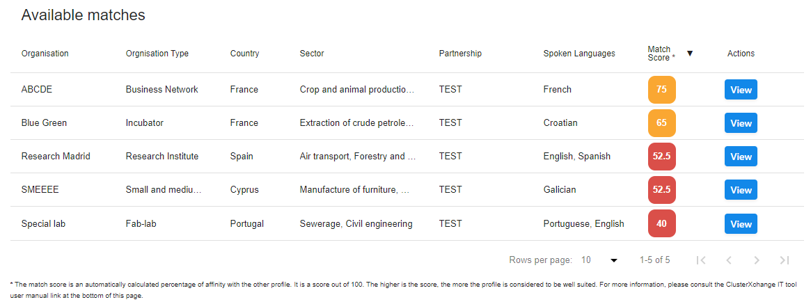
Figure 8: List of available organisations for matching

Initiate and conclude matches

Participants
As part of the search process, users can view the complete profiles of the listed organisations by clicking the 'View' button. On the profile page of the selected organisation (Figure 11), the user can initiate the match by clicking the 'Initiate Match' button or go back to the list by clicking the 'Go Back' button. In case of clicking the 'Initiate Match' button, the chosen counterpart profile owner will receive an email notification of the initiated match. A HO or VO profile owner can initiate multiple matches.

Administrators
Administrators (Partnerships and Support Office (SO)) can initiate matches between VO and HO profiles. To do that, go to the Administrative side of the IT Tool accessible by clicking on the 'Admin' menu item of the main navigation bar, then click on the 'Profiles' menu item in the secondary navigation menu in blue. Here profiles can be matched with counterparts by clicking on the 'Initiate Match' button available on the right side of the table for profiles that are published. The rest of the match initiation process is similar to the one explained above.

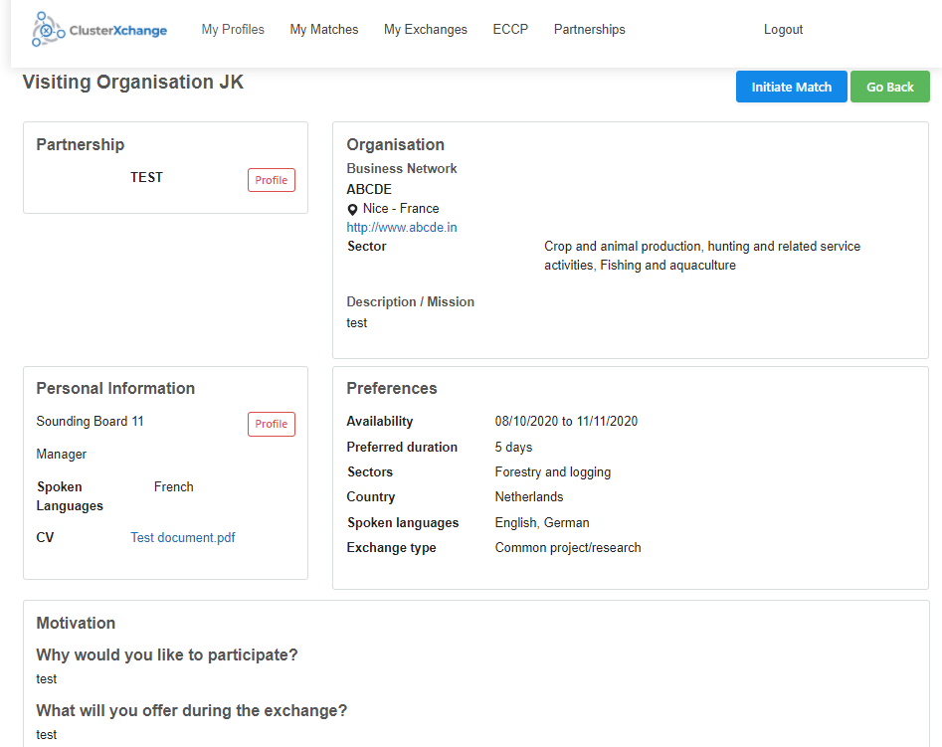
Figure 9: VO initiating a match with an HO
After clicking the 'Initiate Match' button, a validation screen appears that provides a synopsis of the match. In this page there is a messaging tool that allows participants to exchange information and decide if they want to proceed together in creating an exchange.
After agreeing on the match, the process moves out the IT Tool without any validation steps (the participants must not validate the match on the IT Tool). The HO and VO should send an email to the Partnership(s) in charge about the agreed match and their wish to proceed to exchange building.

Exchange building
After the participants have matched via the IT Tool, the administration of the exchange process moves outside of the IT Tool. This phase is focused on developing, signing and quality checking the Commitment to Quality. Visitors in virtual exchanges are not eligible to receive financial assistance and, therefore, the signature of a Financial Agreement is not required. The overview of the process is below.

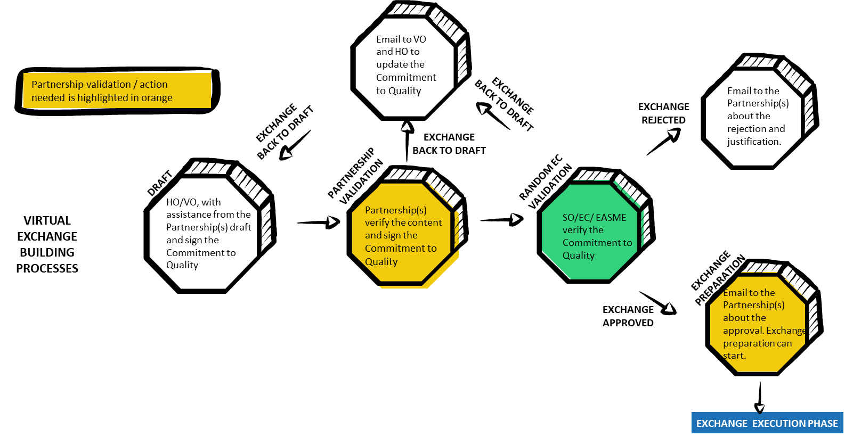
Figure 10: Overview of the exchange building process

Draft
- Partnership(s) should provide participants with the template of the Commitment to Quality (Annex 1).
- Partnerships should inform the SO of the exchange under preparation at the start of the exchange building process for.
- Registering the details of each exchange (VO name, HO name, Partnership(s) in charge, planned start and end date of the exchange) by the SO.
- Agreeing on the timeline for the “EC Validation” of the Commitment to Quality (section 6.3);
- Clarifying any doubts/requesting support from the SO, if applicable.
- The VO and HO, with the assistance from the Partnership(s) in charge, are required to fill in the Commitment to Quality. Note that the details of the HO and VO in the Commitment to Quality should be the same as the data in the participants´ profiles registered in the IT Tool.
- When virtual exchanges are developed in a group, the HO is required to sign a separate Commitment to Quality with each VO.

Partnership Validation
- When the Commitment to Quality is approved by the participants, the Partnership(s) in charge should validate the document. Partnership(s) can send the document back to draft for completion/adjustment or approve and sign the document, if in agreement.

Random EC Validation
- The SO, the European Commission (EC) and the Executive Agency for Small and Medium-sized Enterprises (EASME) will check the Commitments to Quality. This process will not be random for the first set of exchanges. This means the all Commitments of Quality will be checked in the initial phase.
- Partnerships should send the Commitment to Quality to the SO by email for this verification according to the timeline agreed in section 6.1. As a result of the verification, the SO can request the Partnership(s) for the completion/adjustment of the Commitment to Quality, reject if not in line with the CXC rules or approve it. In case of approval, the exchange can take place.

Exchange Preparation
- In case any aspects of the planned exchanges change during the preparation phase, Partnerships should inform the SO.

Exchange execution
This process is focused on performing and concluding the exchange and it is administered outside the IT Tool in case of virtual exchanges. The overview of the exchange execution process is below.
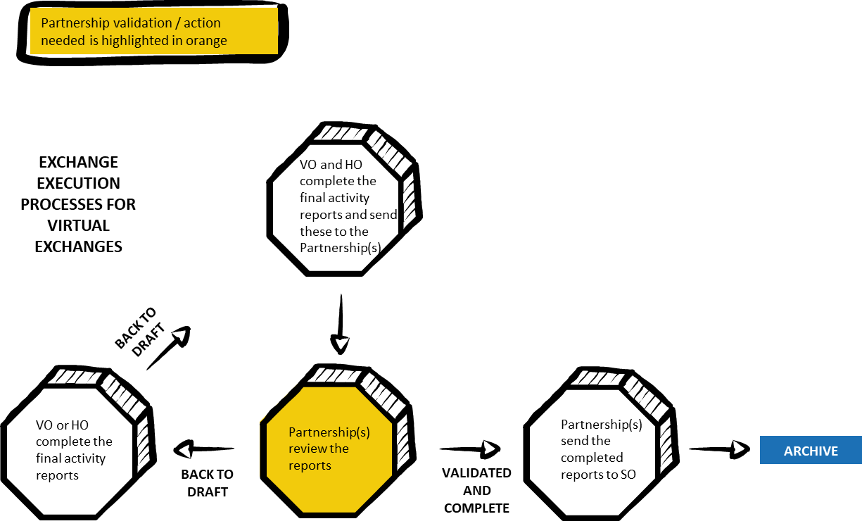
Figure 11: Overview of the exchange execution process
- Partnership(s) in charge should provide the HO and VO with the final activity report templates (Annex 2 and 3, respectively) to fill in after the exchange.
- When receiving the filled in final activity reports from the HO and VO, Partnership(s) in charge can either request further information from the participant(s) (Back to draft) or approve the exchange if both HO and VO final activity reports are complete.
- In case an exchange is approved, the Partnership(s) in charge should inform the SO and send the respective final activity reports for the record and for statistical purposes.

Annex 1. Commitment to Quality for virtual exchanges

1. Details of the Visiting Organisation
Name of the representative participating in the exchange:
Name of the organisation:
Name of the Cluster Organisation of which the organisation is a member (if applicable):
Contact details:
VOP :

2. Details of the Host Organisation
Name of the representative participating in the exchange:
Name of the organisation:
Name of the Cluster Organisation the organisation is a member of (if applicable):
Contact details:
HOP:

3. Summary of the proposed exchange
Type of the virtual exchange: | ☐ Capacity building ☐ Market research  ☐ Research, development and innovation  ☐ Networking and Events  ☐ Mentoring  ☐ Other: Click or tap here to enter text.
Duration of the virtual exchange (in working days):
Planned start date:
Planned end date:

Objectives
Please outline the overall and specific objectives for the exchange (including the individual objectives of the participants).

Agenda
Please outline a detailed agenda of the virtual exchange. Please also identify actions in the post-exchange period where relevant (mid- and long-term).

4. Commitment by the parties
By signing this document, the Visiting Organisation, Host Organisation and their Partnership(s) confirm that they will abide by the principles of the commitments below.

The Visiting Organisation agrees to:
- Comply with all arrangements set for the virtual exchange in order to achieve the stated expected outcome. In particular, execute the agreed agenda within the set timeframe.
- Keep the Host Organisation and the Partnership informed of any circumstances that may affect the implementation of the virtual exchange.
- Seek solutions for any problems/conflicts, jointly with the Host Organisation.
- Submit a report in the specified format within 10 days after the completion of the exchange.
- Keep the content of this Commitment to Quality confidential.
The Host Organisation agrees to:
- Comply with all arrangements set for the virtual exchange in order to achieve the stated expected outcomes. In particular, execute the agreed agenda within the set timeframe and related tasks/responsibilities within the set timeframe.
- Keep the Visiting Organisation and the Partnership informed of any circumstances that may affect the implementation of the exchange.
- Seek solutions for any problems/conflicts, jointly with the Visiting Organisation.
- Submit a report in the specified format within 10 days after the completion of the exchange.
- Keep the content of this Commitment to Quality confidential.
The Partnership of the Visiting Organisation agrees to:
- Provide the Visiting Organisation with an information kit such as any relevant market information related to the host country/region.
- Be available to answer the questions of the Visiting Organisation concerning the exchange.
- Support the Visiting Organisation if any problems arise during the exchange implementation.
- Monitor the progress of the implementation of the exchange.
- Keep the content of this Commitment to Quality confidential.
The Partnership of the Host Organisation agrees to:
- Keep the Host Organisation informed about the ClusterXchange rules and procedures.
- Be available to answer the questions of the Host Organisation concerning the exchange.
- Support the Host Organisation if any problems arise during the exchange implementation.
- Monitor the progress of the implementation of the exchange.
- Keep the content of this Commitment to Quality confidential.

The Visiting Organisation:
I agree with the exchange and applicable commitments in this document.
Name and Signature of the authorised representative(s) of the VO, Date:

The Host Organisation:
I agree with the exchange and applicable commitments in this document.
Name and Signature of the authorised representative(s) of the HO, Date:

The Partnership of the Visiting Organisation
I agree with the exchange and applicable commitments in this document.
Name and Signature of the authorised representative(s) of the VO’s Partnership, Date:

The Partnership of the Host Organisation:
I agree with the exchange and applicable commitments in this document.
Name and Signature of the authorised representative(s) of the HO’s Partnership, Date:

Annex 2. Final activity report for virtual exchanges – Host Organisation

Details of the Organisation
Name of the Representative participating in the exchange:
Name of the organisation:
Name of the Cluster Organisation the organisation is a member of (if applicable):
Contact details:
HOP:
Exchange dates:

Your responses to this questionnaire will help us improve the ClusterXchange scheme and better adapt it to the host organisations´ needs.

Please note that the questionnaire has two parts:
- Part A collects your feedback about the virtual exchange.
- Part B collects your feedback about the scheme. This part is not visible to your Partnership.

Please note that none of your responses are visible to the visiting organisation that participated in the exchange.

Part A. Evaluation of the exchange

- Activities

  - the activities performed during the exchange

b) Deviations from the planned activities (if any)

- Please indicate to what extent the exchange objectives defined in the Commitment to Quality were achieved.

Fully To some extent Not sufficiently Not at all
Please explain briefly which objectives have been / have not been met and why:

- Please identify how you benefitted from the exchange.

 | Significantly | Moderately | Not sufficiently | Not at all
Increased the visibility of your organisation, services and products in relevant communities
Shared your knowledge, experience and information in specific areas
Learned new skills and knowledge from your visitor(s)
Expanded your network of contacts
Developed new cross-border partnerships
Gained knowledge on visitor(s)´ foreign market(s)
Developed business collaboration(s)
Other (optional):
Other (optional):
Other (optional):
Please include any comments.

- Assessment of choice for hosting the exchange

  - How relevant were the following factors when deciding to host the exchange?

 | Very relevant | Quite relevant | Moderately relevant | Irrelevant
Visitor(s)´ sector(s) of activity
Visitor(s)´ organisation type(s) / business activities
Visitor(s)´ knowledge and experience
Command of the language used communicate with the visitor(s)

Other (optional)

- Please evaluate the duration of the virtual exchange.

Too long Optimal Too short

- Share your success story! (optional)

Part B. Evaluation of the scheme

- Please indicate your overall satisfaction with the scheme.

Very satisfied Satisfied Not satisfied Not at all satisfied
If you are “not satisfied” or “not satisfied at all”, could you please provide what is the reason for it? Which difficulties did you encounter and what are your suggestions for improvement (optional)?

- How well did the virtual exchange go?

a) Did you encounter any problems during the virtual exchange?

Yes No

Please explain (optional)

b) If yes, were you able to overcome these problems?

Totally | Mostly | Not really | Not at all

Please explain (optional)

- Please rate the services offered to you in the framework of this scheme.
 | Very good | Good | Average | Poor
Promotion of the scheme
Documentation available on the website
ClusterXchange IT Tool (registration)
ClusterXchange IT Tool (database of searching for potential visitors)

Other (optional)

- Please rate the support provided by your Partnership.

 | Very good | Good | Average | Poor
Clarification of questions and doubts
Assistance to search for potential visitors
Support to establishing the Commitment to Quality (agenda, expected outcomes)
Preparatory activities organised before the virtual exchange
Support in case of difficulties

Other (optional)

- What would you suggest to improve in the ClusterXchange scheme?

 | Very important | Important | Useful | Not a problem
Broader scope of the scheme (objectives and types of activities covered)
More types of organisations allowed to participate
Simpler administrative procedure

Other (optional)

- Please share with us any additional comments (optional).

Please note that all former exchange participants will automatically become ClusterXchange Alumni Network members. In case you would not like to participate, please opt-out below.

I would not like to become part of the ClusterXchange Alumni Network.

Thank you for your feedback!

Annex 3. Final activity report for virtual exchanges – Visiting Organisation

Details of the Organisation
Name of the Representative participating in the exchange:
Name of the organisation:
Name of the Cluster Organisation the organisation is a member of (if applicable):
Contact details:
VOP:
Exchange dates:

Your responses to this questionnaire will help us improve the ClusterXchange and better adapt it to the visiting organisations´ needs.

Please note that the questionnaire has two parts:
- Part A collects your feedback about the virtual exchange.
- Part B collects your feedback about the scheme. This part is not visible to the VOP.

Please note that none of your responses are visible to the organisation that hosted your exchange.

Part A. Evaluation of the virtual exchange

- Activities

  - the activities performed during the exchange

b) Deviations from the planned activities (if any)

- Please indicate to what extent the exchange objectives defined in the Commitment to Quality were achieved.

Fully To some extent Not sufficiently Not at all
Please explain briefly which objectives have been / have not been met and why:

- Please identify how you benefitted from your participation in the exchange.

 | Significantly | Moderately | Not sufficiently | Not at all
Broadened your sector- and non-sector specific skills and knowledge
Gained insights into the operation and techniques used by your host
Expanded your network of contacts
Developed new cross-border partnerships
Found innovative solutions to upgrade your business, products and services
Created new business opportunities
Got involved in new innovative projects
Gained knowledge on foreign markets and cultures
Other (optional):
Other (optional):
Other (optional):
Please include any comments.

- Assessment of your choice of the host

  - How relevant were the following factors for your and your organisation´s professional development?

 | Very relevant | Quite relevant | Moderately relevant | Irrelevant
Host´s sector of activity
Host´s organisation type / business activities
Host´s knowledge and experience
Command of the language used communicate with the host

Other (optional)

- Please evaluate the duration of the virtual exchange.

Too long Optimal Too short

- Share your success story! (optional)

Part B. Evaluation of the scheme

- Please indicate your overall satisfaction with the scheme.

Very satisfied Satisfied Not satisfied Not at all satisfied
If you are “not satisfied” or “not satisfied at all”, could you please provide what is the reason for it? Which difficulties did you encounter and what are your suggestions for improvement (optional)?

- How well did your virtual exchange go?

a) Did you encounter any problems during the exchange?

Yes No

Please explain (optional)

b) If yes, were you able to overcome these problems?

Totally | Mostly | Not really | Not at all

Please explain (optional)

- Please rate the services offered to you in the framework of this scheme.

 | Very good | Good | Average | Poor
Promotion of the scheme
Documentation available on the website
ClusterXchange IT Tool (registration)
ClusterXchange IT Tool (database of searching for potential hosts)

Other (optional)

- Please rate the support provided by your Partnership

 | Very good | Good | Average | Poor
Clarification of questions and doubts
Assistance to search for potential hosts
Support to establishing the Commitment to Quality (agenda, expected outcomes)
Preparatory activities organised before the virtual exchange

Other (optional)

- What would you suggest to improve in the ClusterXchange scheme?

 | Very important | Important | Useful | Not a problem
Broader scope of the scheme (objectives and types of activities covered)
More types of organisations allowed to participate
Simpler administrative procedure

Other (optional)

- Please share with us any additional comments (optional).

Please note that all former exchange participants will automatically become ClusterXchange Alumni Network members. In case you would not like to participate, please opt-out below.

I would not like to become part of the ClusterXchange Alumni Network.

Thank you for your feedback!

ClusterXchange pilot scheme -Quality Manual for European Strategic Cluster Partnerships for Excellence (ESCP-4x)
European Strategic Cluster Partnership for Excellence in charge of the Visiting Organisation
European Strategic Cluster Partnership for Excellence in charge of the Host Organisation
A virtual exchange does not have to take place in consecutive days but it must be done within a certain period of time, depending on the length of the exchange. The exchange must be implemented within 2X weeks equal to the X of planned working days of an exchange. For example, if a 4 working day exchange is planned, it must be implemented within 8 weeks – e.g. 8 half days sessions within an 8-week period.
European Strategic Cluster Partnership for Excellence in charge of the Host Organisation
Include the agenda from Commitment to Quality
European Strategic Cluster Partnership for Excellence in charge of the Visiting Organisation
Include the agenda from Commitment to Quality

